The website used for online meet entries, as well as to look up swimmers stop times is, http://www.swimconnection.com/pc/

Entering meets
Click the Enter Meets button on the home page of Swim connection, then press the “go to the new online meet entry site”.
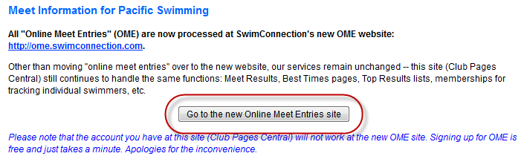
Here you will find a list of offered meets as well as the status of “OPEN” or “CLOSED”. A meet must be open to be able to enter a swimmer into this met. Only enter meets approved by your coach, if a swimmer is entered in, and participates in a meet that is not a “team meet” where your coach is present, this can result in a fine from Pacific Swimming.
First thing first, if you do not already have an account, make sure to hit the “REGISTRATION BUTTON” and create one.
When you find the meet you are looking for, click the link for that meet.
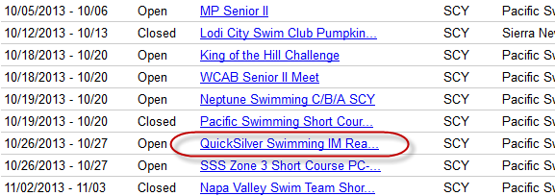
Next page hit “ONLINE MEET ENTRY”
Next page is where you will enter your swimmer. If you already have a swimmer registered to your account, you can use the “group” drop down to select your swimmer. If not, you must hit the “Enter Swimmer” Button
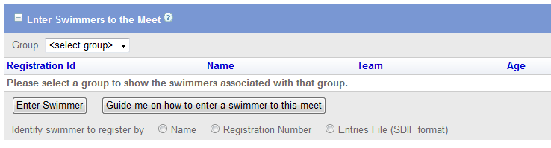
If your swimmer is Registered with USA swimming you can easily search by name, or enter their registration number. If not then you need to click “Guide me on how to enter a swimmer into this meet”. You will select bullet “NO” for “is your swimmer registered with USA swimming”. Then fill out the following information.
Registration No should reflect birthdate (mm/dd/yy then first three letters of first name, first letter of middle name and first four of last name. Any areas that there are not enough letters will be replaced by a * (Example: Aynsley T Perry 112604AYNTPERR) If Aynsleys last name is NA it would reflect 112604AYNTNA**)
You must then select Pending. (Registration must be sent to Pacific Swimming with the registration check before the swim meet. If it is within 2 weeks, register and pay for registration at the swim meets check in.)
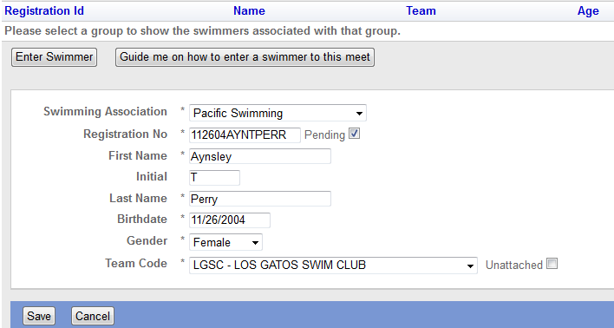
After this is done you will be taken to a page that lists the possible events. Easiest way is to just hit “best” for every event you wish to enter your swimmer in. After events are entered make sure to hit the go to payment option to complete the meet entry.

If you have any questions please see a coach.

